Screenshots:

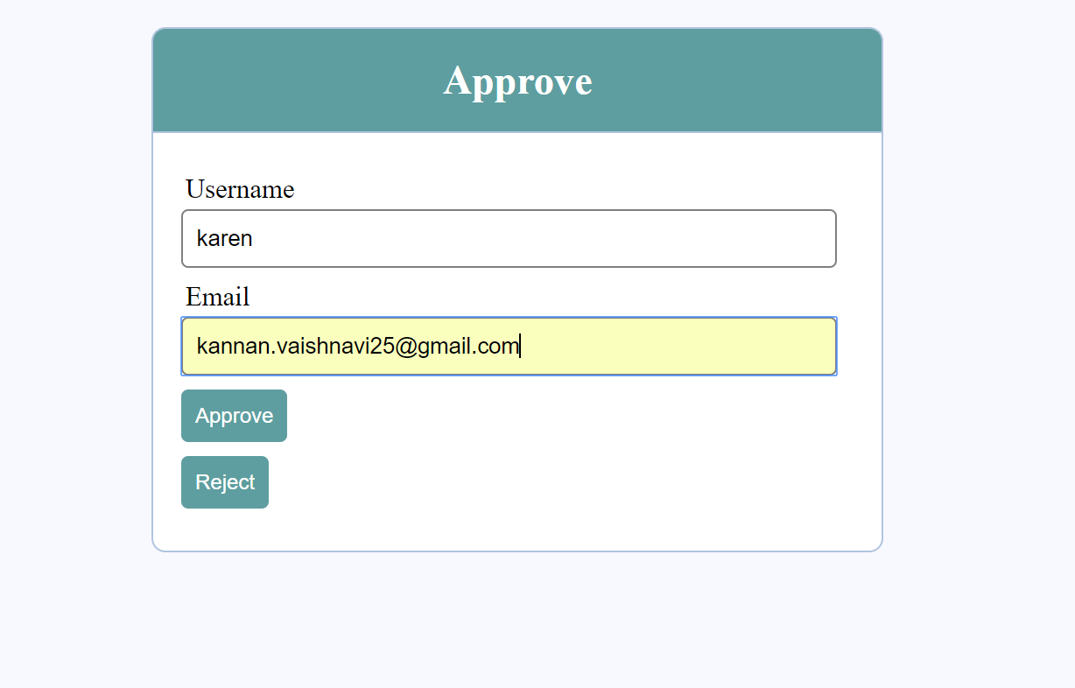

On Acceptance, the user ‘jessie’s record is removed from users database and added to Teachers database.

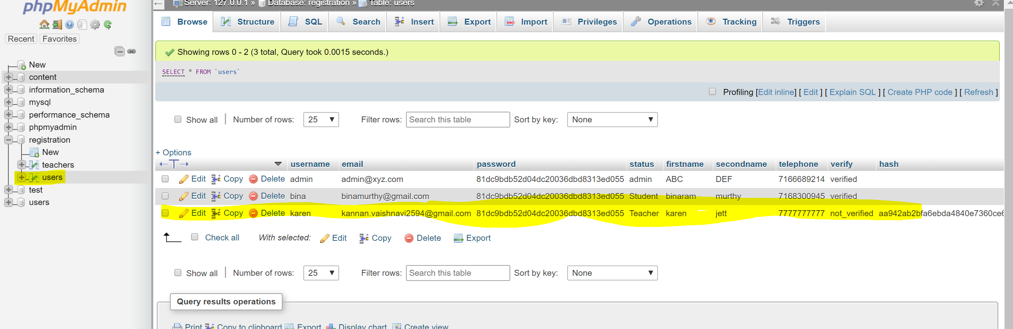

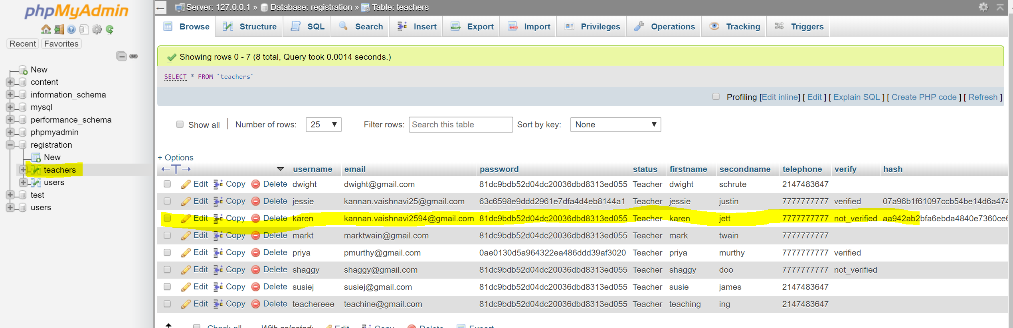

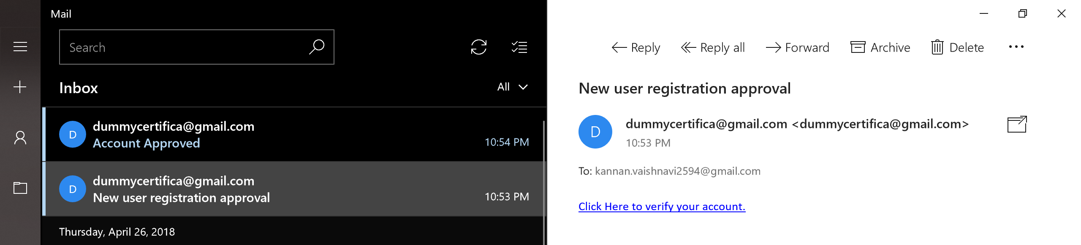

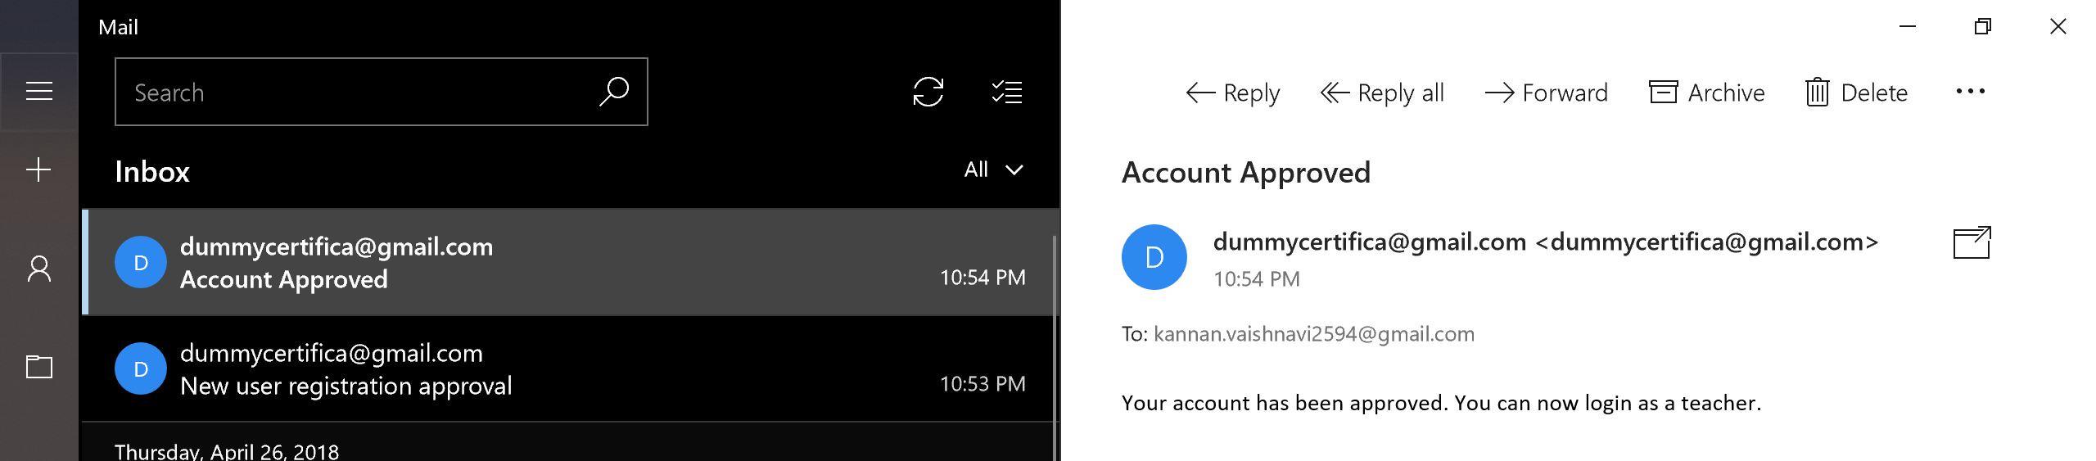

On clicking verify your account link:-

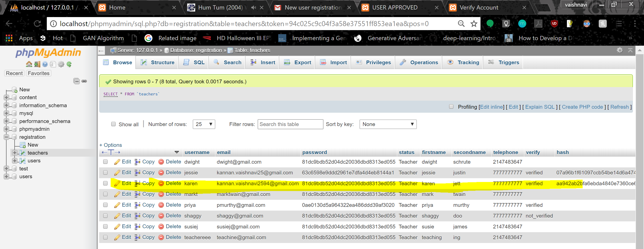

Users cannot login until their account is verified:

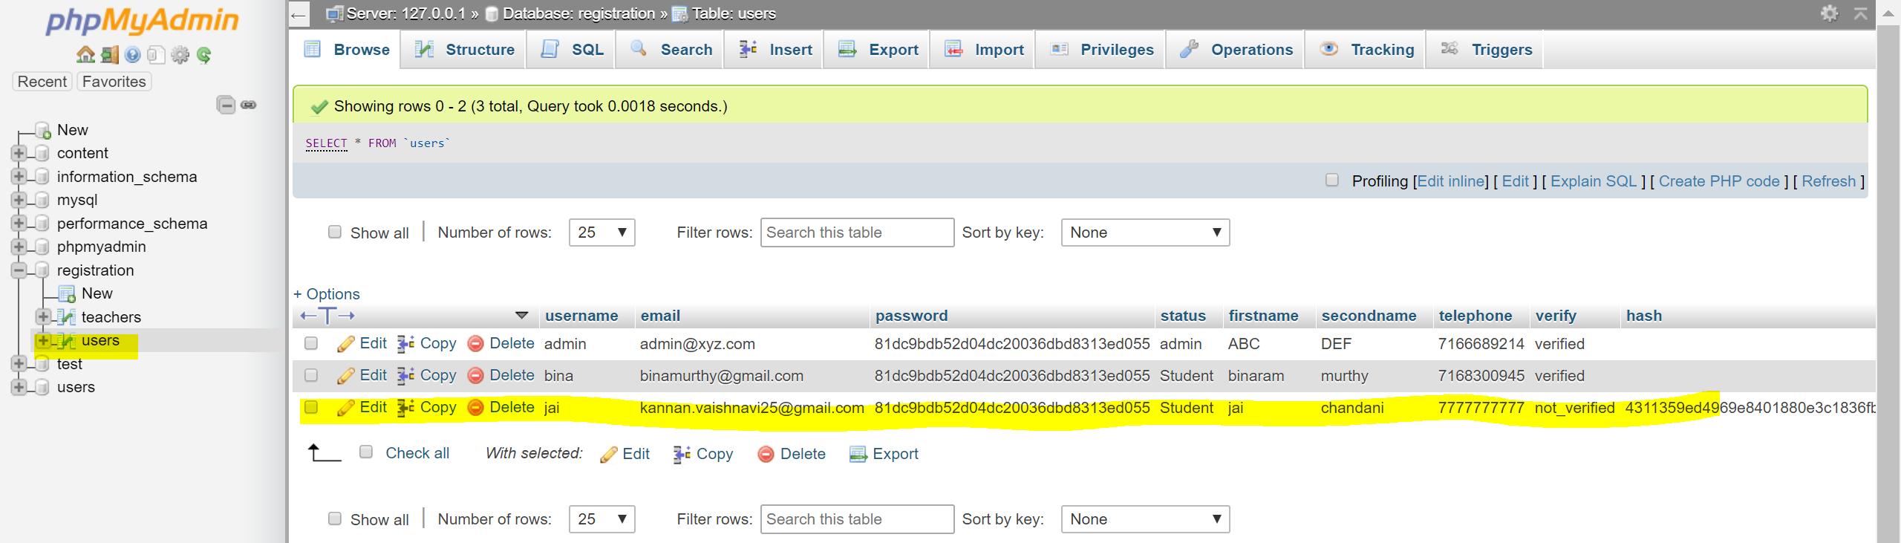

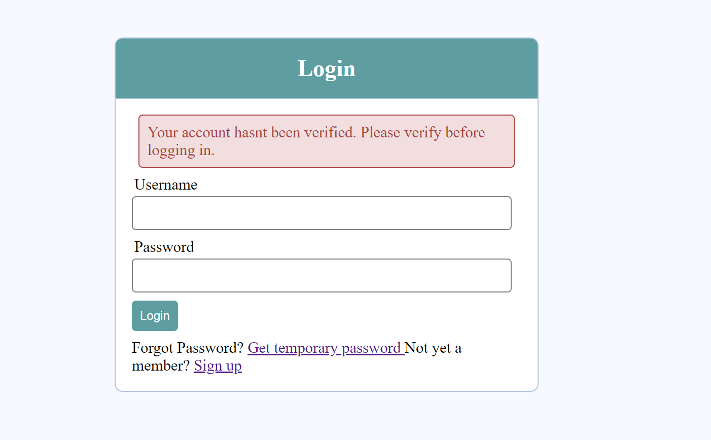

Forgot password:-

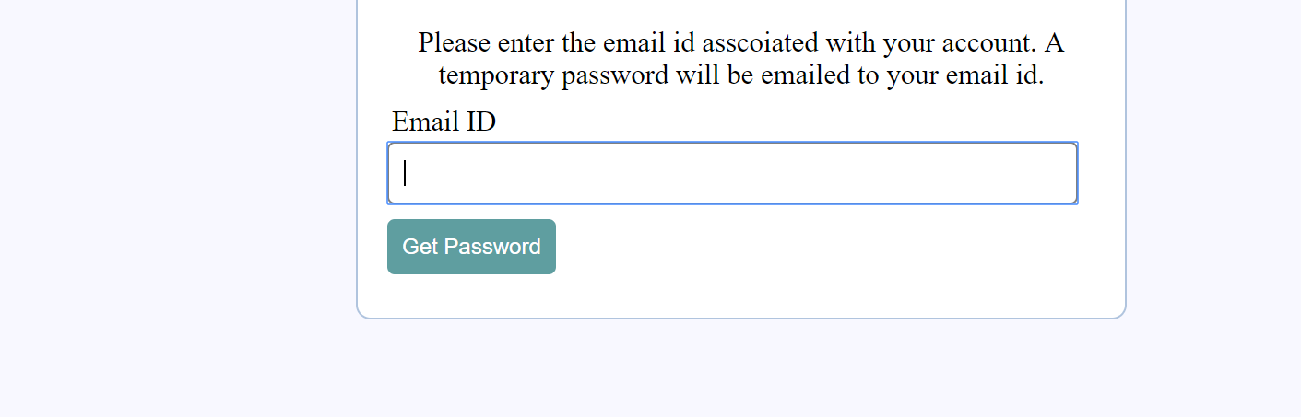

On entering the email id:

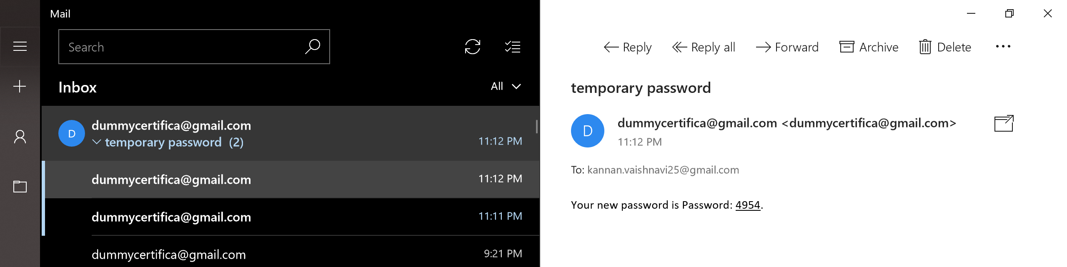

Password hash before password is changed:

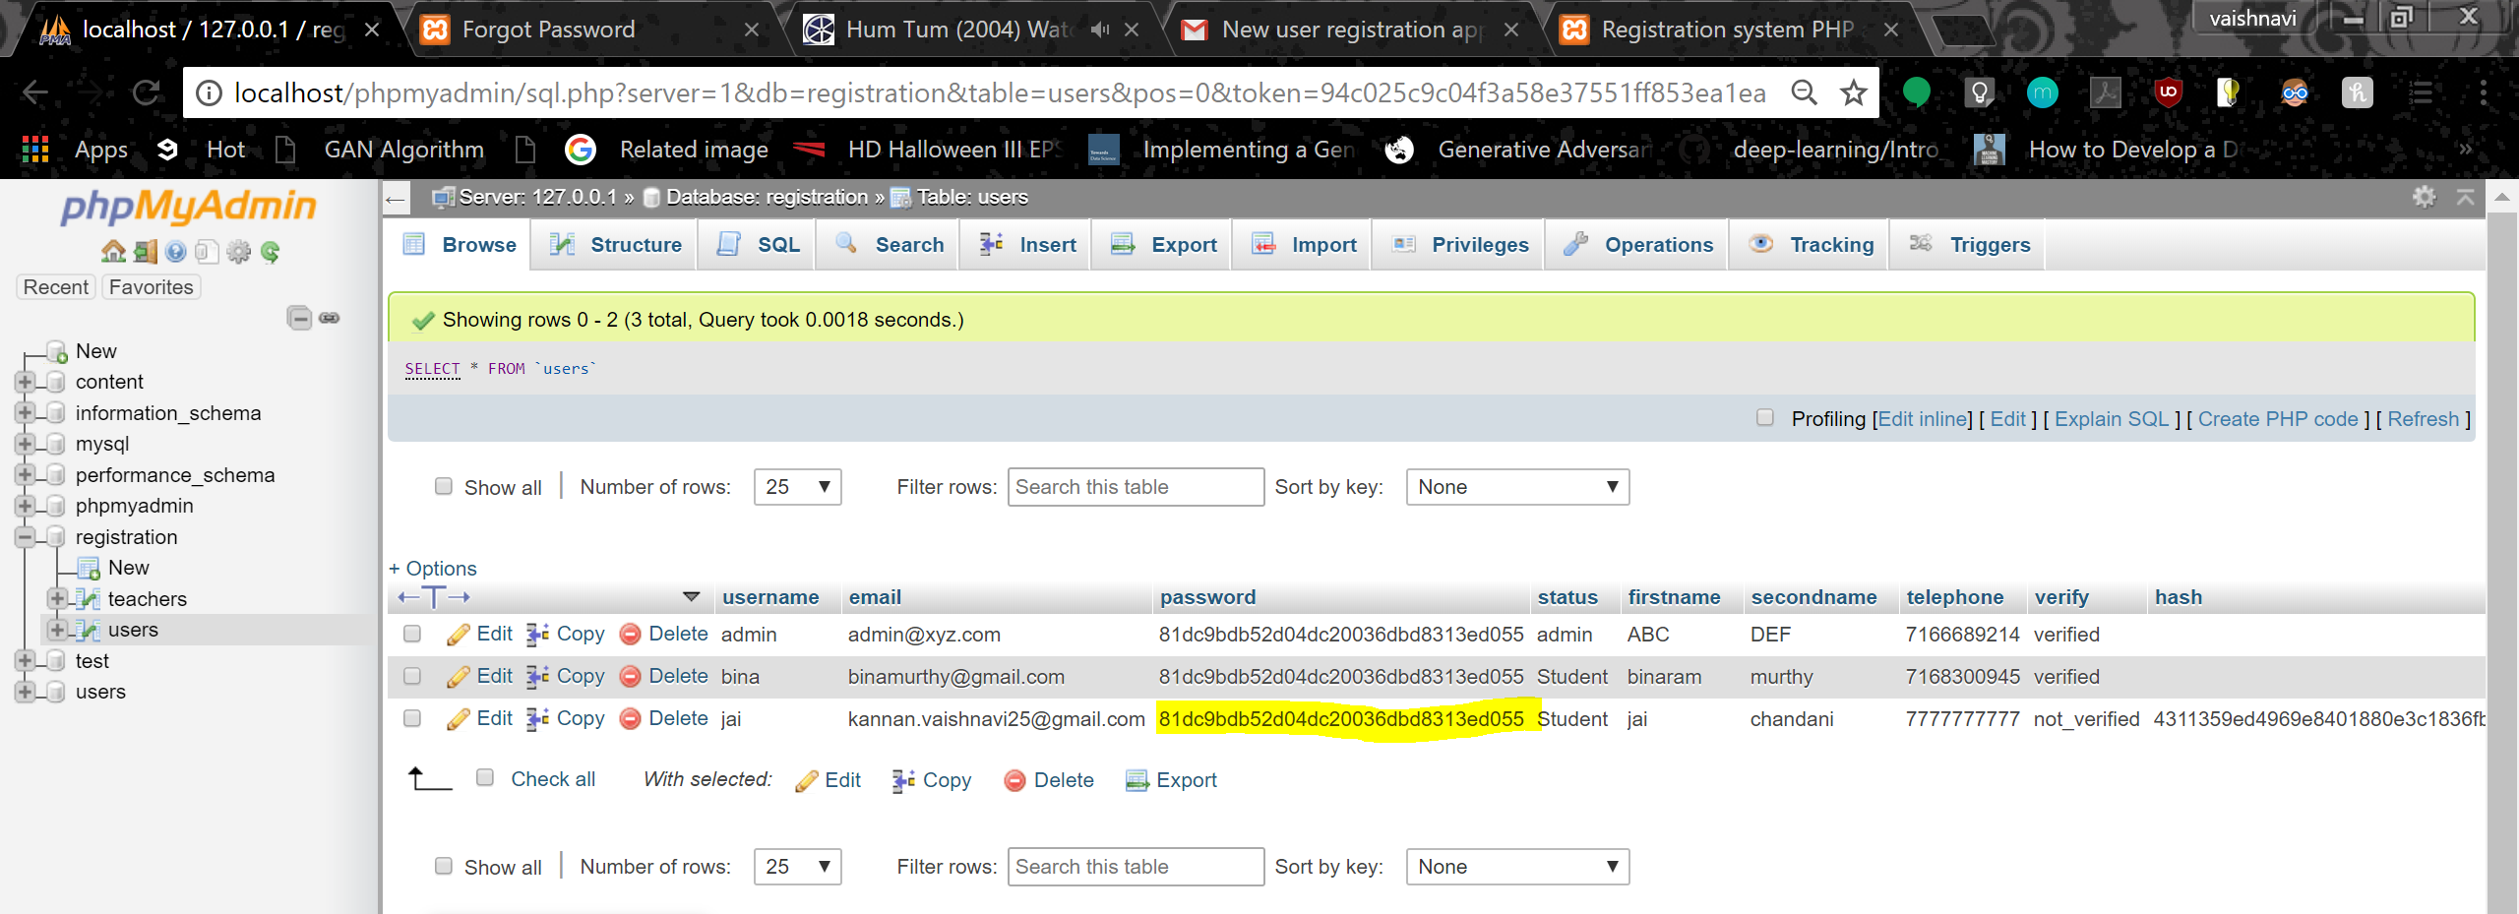

Password hash changed to hash of temporary password:-

